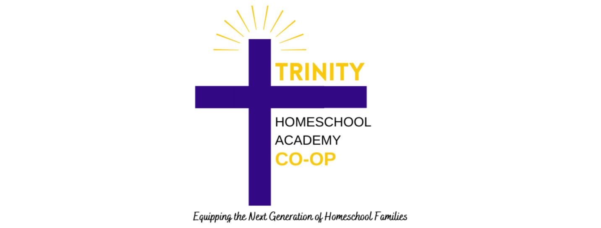
THSA Release of Liability and General Agreement ____________________________________________________________________________
THSA https://www.trinityhomeschoolsacademy.com/co-op
In consideration of being permitted to participate in THSA classes and Field trip events,
List all family members here:
____________________________________________________________________________
____________________________________________________________________________
____________________________________________________________________________
(Hereinafter referred to as “Family”) agree to the following: Release, waive, discharge, and covenant not to sue the THSA, the officers, owners, employees, board members, or other families participating in the Classes (hereinafter referred to as “Releases” from all liability to Family for any loss or damage and any claim or damage on account of injury to the person or property or resulting in the death of a Family member while Family is participating in the THSA classes or any other activities on the premises of International Praise Church or that occur during a THSA sponsored field trip. Family agrees to indemnify Releases from any loss, liability, damage or cost Release may incur due to the presence of Family in or on IPCOG premises. Family releases transportation to and from the classes or any time off the premises is the Family’s responsibility. Family assumes full responsibility for and risk of bodily injury, death or property damage while in or on the premises of IPCOG and/or working or for any purpose participating in the activities (classes or fieldtrips) of the THSA. Family expressly agrees that this release, waiver, indemnity agreement is intended to be as binding and inclusive as permitted by the laws of the State of South Carolina and that, if any portion of the agreement is held invalid, it is agreed that the balance shall, notwithstanding, continue in full legal force and effect. Family, in consideration of being permitted to participate in the classes, for Family, and Family’s heirs, executors, administrators, and assigns, releases and forever discharges all Releases, and their heirs, administrators, and executors of and from any and every claim, demand, action or right of action, of whatsoever kind or nature, either in law or in equity arising from or by reason of any bodily injury or personal injuries known or unknown, death or property damage resulting or to result from any accident which may occur as a result of participation in the THSA classes or any activities in connection with the THSA. Family states that Mother, Father or legal guardian of Family has carefully read the above release and knows the contents of the release and signs this release as Family’s own free act. Family releases all officials and professional personnel from any claim whatsoever on account of first aid, treatment or service rendered during participation in the THSA classes. This agreement shall be binding on each member of the Family, their personal representatives, assigns, heirs, and next of kin. This release contains the entire agreement between parties to this agreement and the terms of this release are contractual and not a mere recital.
Printed Name:_________________________________________________________

________________________________________ __________________
Signature Date
________________________________________ __________________
Signature Date

